Analysis of Zeus Banking Trojan Report

Lab/Project

Ali Charty

2024

**Fingerprint**

Screenshot showing the VirusTotal analysis results for the Zeus Trojan sample, identifying it as malicious based on multiple antivirus engines.

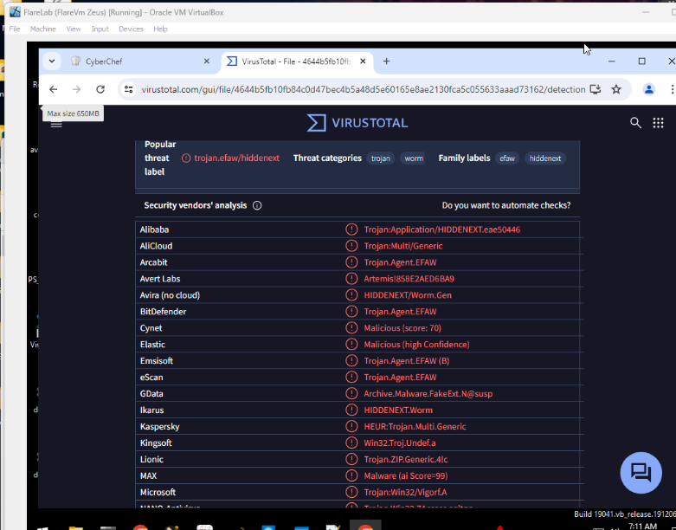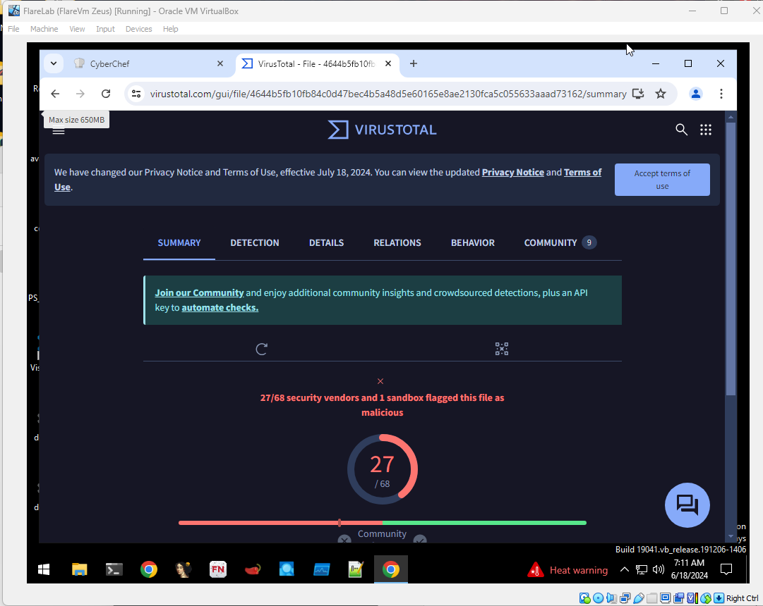

Hashes:

Screenshot of PE Studio displaying the calculated hashes (MD5, SHA-1, SHA-256) for the Zeus Trojan sample.

Invoice_2318362983713_823931342io.pdf.exe

**Basic Static Analysis**

Pestudio

corect.com yielded no interesting findings. (Romanian)

API calls

List of API calls extracted from the Zues Trojan, including descriptions of their functionality.

GetAsyncKeyState: Determines whether a key is up or down at the time the function is called, and whether the key was pressed after a previous call to **GetAsyncKeyState**.

SHLWAPI.dll

KERNEL32.dll

USER32.dll

Capa Output

Screenshot of the Capa tool output, showing the capabilities of the Zeus Trojan and mapping them to the MITRE ATT&CK framework.

**Advanced Static Analysis**

Screenshot of Cutter tool, pinpointing the location of Kernel32.dll within the disassembled code of the Zeus Trojan.



**Basic Dynamic Analysis**

Screenshot from Process Monitor, displaying the process tree and highlighting the parent-child relationship between malicious processes spawned by the Zeus Trojan.

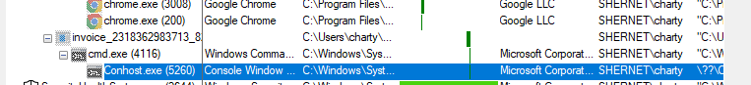

Screenshot from Process Monitor, showing a hidden command line session created by the Zeus Trojan for executing commands.

Network based indicator

Screenshot from Wireshark, capturing the network traffic generated by the Zeus Trojan and highlighting any suspicious connections.

**YARA (IOC)**

Yara rule created for detecting the Zues Trojan, based on unique strings and characteristics identified during the analysis.

